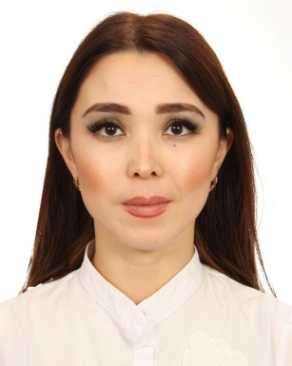
Personal information
First name(s) / Surname(s) | Omarova Ainura
Address(es) | 92 Zhambyl street, 100000, Karaganda, Kazakhstan
Telephone(s) | +7 (7212) 300 286, + 7 778 108 86 96 | Mobile: | +7 778 108 86 96
E-mail | ainuraphd@mail.ru
International Experience | 2010-2011 - Master degree with academic mobility at the Carinthia University of Applied Sciences (Austria)
 | 2011 – Internship at the Institute for Economy (Berlin) for 3 months under the guidance of professor W.D. Hartmann (Germany)
 | 2013 – Internship at the University of Santiago de Compostela under the guidance of professor M.F. Grela (Spain)
 | 2017 – Internship at the University of Craiova under the guidance of professor M.Constantinescu (Romania)
 | 2018 – Internship at the Universitat Oberta de Catalunya (Spain within Erasmus+ program)
 | 2018 – Internship with academic teaching mobility at the Kodolanyi Janos University of Applied Sciences (Hungary within Erasmus+ program)
 | 2018 – Internship at the University of Craiova to the INCESA laboratory (Romania)
 | 2018 – Internship at the Vienna University of Economics and Business within Erasmus+ program CACTLE (online course of “Certified University Teacher”)
 | 2017 – Coordinator of the project Central Asian Center for Teaching, Learning and Entrepreneurship (CACTLE provided by Erasmus +)

